Following errors were occurred when running the matlab code:

1. matlab videoreader unable to determine the codec required

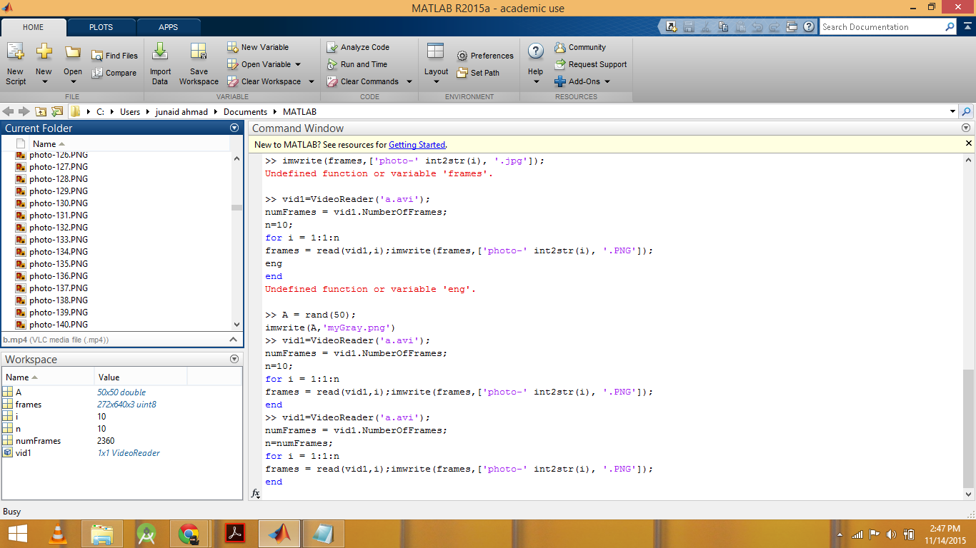

Solution:

* 1. Identified the codec required i-e Xvid
  2. Downloaded the Xvid from [**http://en.softonic.com/s/free-download-windows-8.1-xvid**](http://en.softonic.com/s/free-download-windows-8.1-xvid)
  3. Intstalled Xvid codec.